Embargoed until May 16th, 2025

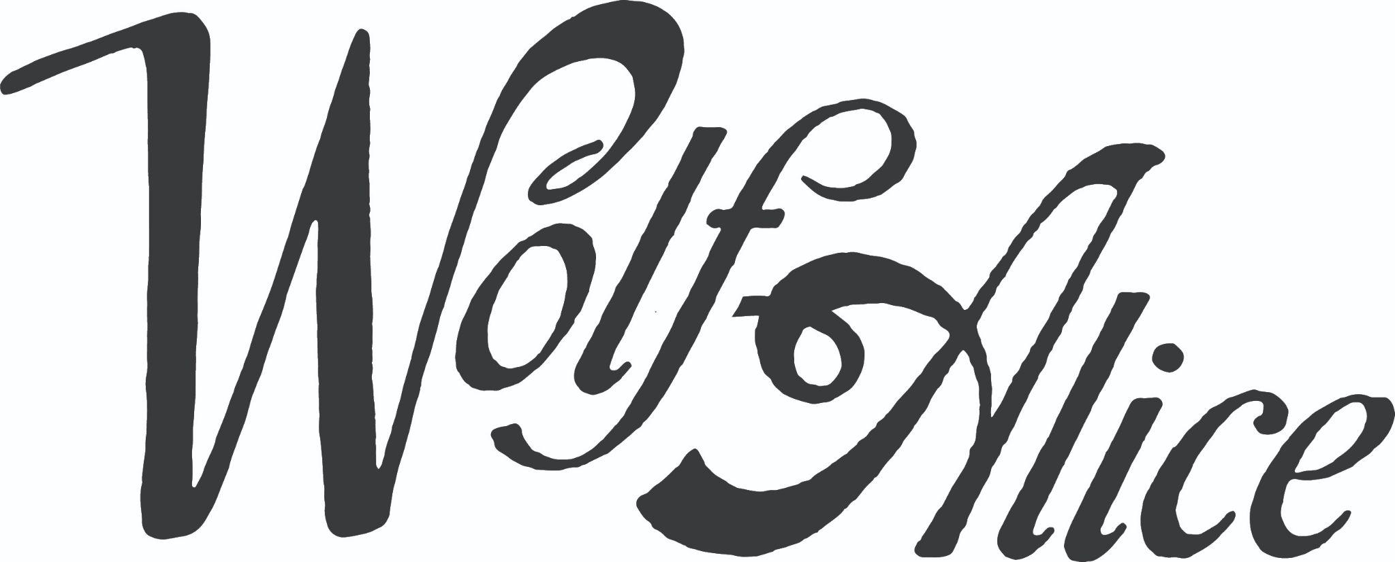

The Clearing Short Biog 2025

North London quartet Wolf Alice first emerged in 2013 with the bruised euphoria of their debut album My Love Is Cool, which featured the Grammy-nominated ‘Moaning Lisa Smile’. 2018’s follow up Visions Of A Life cemented their rise with a Mercury Music Prize win, before the precious hurt of 2022’s Blue Weekend and its resultant number 1 in the UK album charts and Brit Award for Best Group.

August 29th, 2025 will see the release of Wolf Alice’s fourth album The Clearing via their new global label home, Sony Music and finds them at the peak of their powers, grown into a band of significant cultural importance. Written in Seven Sisters, North London and recorded in LA with Grammy-winning, master producer Greg Kurstin last year, The Clearing reveals where Wolf Alice stand sonically in 2025, delivering a supremely confident collection of songs bursting with ambition, ideas and emotion; The Clearing is a truly timeless record.

Both playful and serious, ironic and straight-talking,The Clearing is a progressive shift from a band whose exploration of love, loss and human connection has already articulated the coming-of-age experience for a whole generation. It’s a classic pop/rock album that nods to the ‘70s while remaining rooted firmly in the present. If Fleetwood Mac wrote an album today in North London, you’d get somewhere close to this run of effortlessly grand tracks, each as distinct as the last. Sonically, there is no waste, no fuss, with more authoritative melodies than the band has ever crafted before. This is a new beginning, and each of the band feels it as keenly as listeners will.

Across their career, Wolf Alice have toured the world multiple times on headline sold out tours, gracing numerous festival stages and supporting an array of key artists. This summer so far sees confirmed slots at Radio 1’s Big Weekend and Glastonbury with a huge headline world tour scheduled for the end of 2025.

